|  |
| --- |
| Functional Specification Document  <Build a Microsite For NASA> |

**DOCUMENT VERSION <X.X>**

**<07.04.2019>**

**AUTHORS**

|  |  |  |
| --- | --- | --- |
| **Name** | **Role** | **Department** |
| Jørgen Årnes | Project Manager/Business Analyst/ UX & UI designer / Front-End Developer | Noroff |

**DOCUMENT HISTORY**

|  |  |  |  |
| --- | --- | --- | --- |
| **Date** | **Version** | **Document Revision Description** | **Document Author** |
|  |  |  |  |
|  |  |  |  |
|  |  |  |  |
|  |  |  |  |
|  |  |  |  |

**APPROVALS**

|  |  |  |  |
| --- | --- | --- | --- |
| **Approval Date** | **Approved Version** | **Approver Role** | **Approver** |
|  |  |  |  |
|  |  |  |  |
|  |  |  |  |
|  |  |  |  |

**Table of Contents**

1. Introduction 3

1.1 Purpose of the document 4

1.2 Project Scope 4

1.3 Scope of the document 4

1.4 Related documents 4

1.5 Terms/Acronyms and Definitions 4

1.6 Risks and Assumptions 4

2. System/ Solution Overview 5

2.1 Context Diagram/ Interface Diagram/ Data Flow Diagram, Application Screen Flow, Sitemap, Process Flow 5

2.2 System Actors 5

2.3 Dependencies and Change Impacts 5

3. Functional Specifications 5

3.1 <Title> 6

4. System Configurations 8

5. Other System Requirements/ Non-Functional Requirements 9

6. Reporting Requirements 9

7. Integration Requirements 9

7.1 Exception Handling/ Error Reporting 9

8. Data Migration/ Conversion Requirements 10

8.1 Data Conversion Strategy 10

8.2 Data Conversion Preparation 10

8.3 Data Conversion Specifications 10

9. References 10

10. Open Issues 10

Appendix 10

# Introduction

## NASA has decided to build a Microsite to raise awareness about space program activity around the world. This microsite is not meant to cover all content but as an addition to the existing website with focus on the World Space Programs like International Space Station, Launces and so forth.

## Purpose of the document

The Functional Specification Document is a document that provides detailed information on *how* the system solution will function and the requested behavior. This document is created based on the high-level requirements identified in the Business Requirements Document and provides traceability on the functional specifications back to the business requirements. Included in this document will be the detailed functional requirements including use cases, system inputs and outputs, process flows, diagrams, and mock ups.

## Project Scope

The expected deliverables and milestones for the project are listed on the Project plan and Gantt chart.

## Scope of the document

*<If there are multiple FSDs created for the project, describe the specific scope that this document will address. Sections 1.2 and 1.3 can be combined together>.*

## 1.4 Related documents

*<Add any related documentation that is relevant and related to the FSD. Some examples are the Project Charter, Business Requirements Document, etc.>.*

|  |  |  |
| --- | --- | --- |
| **Component** | **Name (with link to the document)** | **Description** |
|  |  |  |

## 1.5 Terms/Acronyms and Definitions

*<State any terms and its definition that are described in the functional specifications. Include any acronyms that are mentioned in the document.>*

|  |  |  |
| --- | --- | --- |
| **Term/Acronym** | **Definition** | **Description** |
| ISS | International Space Station |  |

## 1.6 Risks and Assumptions

## Some of the deliverables might be delayed due to new features the developer haven't learned yet and therefor need to learn before he can move on to the next tasks in the project. Although some delay may occur, the developer has not set the actual deadline for the project because he want to see if he’s still able to speed up the work.

# System/ Solution Overview

2.1 Context Diagram/ Interface Diagram/ Data Flow Diagram, Application Screen Flow, Sitemap, Process Flow

*<Provide any appropriate graphical representations that are relevant to the system and project such as a context/interface/data flow diagram, application screen flow, site map, or process flow. Add as many as needed.>*

## 2.2 System Actors

### 2.2.1 User Roles and Responsibilities / Authority Requirements

|  |  |  |  |  |
| --- | --- | --- | --- | --- |
| **User/Role** | **Example** | **Frequency of Use** | **Security/Access, Features Used** | **Additional Notes** |
| * Students * Engineer * Stakeholders * Business Head of Departments * Technical Heads of Departments * Financial Managers | *<include examples of real people in the role>* | *Frequent, Occasional* | *<describe the features of the system available for the role and any security/access permissions that should be stated>* | *<add any additional notes or supporting documentation as necessary>* |

## 2.3 Dependencies and Change Impacts

### 2.3.1 System Dependencies

*<List and identify any dependencies the proposed solution will have on other systems.>*

### 2.3.2 Change Impacts

*<List and identify existing systems that will be impacted by the implementation of the proposed solution.>*

# Functional Specifications

*<Start describing the specifications related to the overall system here. You may want to create a table/ index of all functionalities explained in the sections below and link them to the items below>*

*<If no separate reference/ traceability document is created for the project, use this section to map the business requirements, use cases, functional requirements and the test cases>*

*<Group your functional specifications as appropriate for your project. You may want to divide them by screens, functional areas, user role, JIRA tickets or high-level functions Vs detailed functions or any other way that works for your project>*

## 3.1 < Build a microsite >

### 3.1.1 Purpose/ Description

*<* Build a microsite for NASA that focus on space technology. *>*

### 3.1.2 Use case

*<Map the functional requirement to one or more use cases mentioned in the Business Requirements document. If the use case is not described in detail in the Business Requirements document, describe the use case here. This typically includes the element s in the following table.>*

|  |  |
| --- | --- |
| **UC-1** | **Signifier on the Navigation menu** |
| **Primary Actor(s)** | *Students, Engineers, Stakeholders* |
| **Stakeholders and Interest** | *<One sentence describing other stakeholders>* |
| **Trigger** | Affordance of a navigation bar which get triggered when the mouse is hovered over |
| **Pre-conditions** | *<Condition assumed to be true before the first step>* |
| **Post-conditions** | The signifier end when the mouse cursor is moved away from the navigation area. |
| **Main Success Scenario** | 1. *Enter one of Nasa’s microsite pages* 2. *Move your mouse cursor over one of the navigation buttons* 3. The button signifies for successful hidden affordance with a different background color or shade. |
| **Extensions** | If Condition, then Alternative Steps |
| **Priority** | *<indicate priority of high, medium or low)* |
| **Special Requirements** | *<Any system related special requirements needed to fulfill the use case>* |
| **Open Questions** | *<Notes and questions>* |

|  |  |
| --- | --- |
| **UC-2** | **Links on the Navigation menu** |
| **Primary Actor(s)** | *Students, Engineers, Stakeholders* |
| **Stakeholders and Interest** | *<One sentence describing other stakeholders>* |
| **Trigger** | A single mouse click leads the user to another page |
| **Pre-conditions** | *<Condition assumed to be true before the first step>* |
| **Post-conditions** | The user is successfully sent to another page |
| **Main Success Scenario** | 1. *Enter one of Nasa’s microsite pages.* 2. *Click on one of the navigation buttons* |
| **Extensions** | If Condition, then Alternative Steps |
| **Priority** | *<indicate priority of high, medium or low)* |
| **Special Requirements** | *<Any system related special requirements needed to fulfill the use case>* |
| **Open Questions** | *<Notes and questions>* |

|  |  |
| --- | --- |
| **UC-3** | **The user can search with the search bar** |
| **Primary Actor(s)** | *Students, Engineers, Stakeholders* |
| **Stakeholders and Interest** | *<One sentence describing other stakeholders>* |
| **Trigger** | *The mouse cursor changes to the text cursor when it’s hovering over the search bar and when it’s clicked on we can write on the input field* |
| **Pre-conditions** | *<Condition assumed to be true before the first step>* |
| **Post-conditions** | *Characters like letters, numbers and other symbols appears when we write on the input fields* |
| **Main Success Scenario** | 1. *Enter one of Nasa’s microsite pages*. 2. Click on the search bar. 3. Make a search by writing something |
| **Extensions** | If Condition, then Alternative Steps |
| **Priority** | *<indicate priority of high, medium or low)* |
| **Special Requirements** | *<Any system related special requirements needed to fulfill the use case>* |
| **Open Questions** | *<Notes and questions>* |

|  |  |
| --- | --- |
| **UC-4** | **The user can contact NASA through their contact form** |
| **Primary Actor(s)** | *Students, Engineers, Stakeholders* |
| **Stakeholders and Interest** | *<One sentence describing other stakeholders>* |
| **Trigger** | *<Condition/action that initiates/starts the use-case>* |
| **Pre-conditions** | *<Condition assumed to be true before the first step>* |
| **Post-conditions** | *<Condition after the use case is successfully executed >* |
| **Main Success Scenario** | 1. *Enter Nasa’s contact page* 2. Fill in the at least the required fields 3. Write your message 4. *Send the message by clicking on the send button* |
| **Extensions** | If Condition, then Alternative Steps |
| **Priority** | *<indicate priority of high, medium or low)* |
| **Special Requirements** | *<Any system related special requirements needed to fulfill the use case>* |
|  |  |
| **Open Questions** | *<Notes and questions>* |

|  |  |
| --- | --- |
| **UC-5** | **The user can view a schedule or timeline of previous rocket launches and upcoming ones as well as other space program activities** |
| **Primary Actor(s)** | *Students, Engineers, Stakeholders* |
| **Stakeholders and Interest** | *<One sentence describing other stakeholders>* |
| **Trigger** | *<Condition/action that initiates/starts the use-case>* |
| **Pre-conditions** | *<Condition assumed to be true before the first step>* |
| **Post-conditions** | *<Condition after the use case is successfully executed >* |
| **Main Success Scenario** | 1. From one of Nasa’s microsite pages click on the “Space program” button at the navigation panel. 2. scroll up and down to see space program activities. |
| **Extensions** | If Condition, then Alternative Steps  Click on one of the links from the microsite home page. |
| **Priority** | *<indicate priority of high, medium or low)* |
| **Special Requirements** | *<Any system related special requirements needed to fulfill the use case>* |

|  |  |
| --- | --- |
| **UC-6** | **Database management.** |
| **Primary Actor(s)** | Heads of department |
| **Stakeholders and Interest** | *<One sentence describing other stakeholders>* |
| **Trigger** | *<Condition/action that initiates/starts the use-case>* |
| **Pre-conditions** | *<Condition assumed to be true before the first step>* |
| **Post-conditions** | *<Condition after the use case is successfully executed >* |
| **Main Success Scenario** | 1. *API for retrieving updates of space program* 2. API for *retrieving images and illustrations* |
| **Extensions** | If Condition, then Alternative Steps  <List any extended steps/ scenarios that occur, other than the main success scenario.> |
| **Priority** | *<indicate priority of high, medium or low)* |
| **Special Requirements** | *<Any system related special requirements needed to fulfill the use case>* |

### 3.1.3 Mock-up

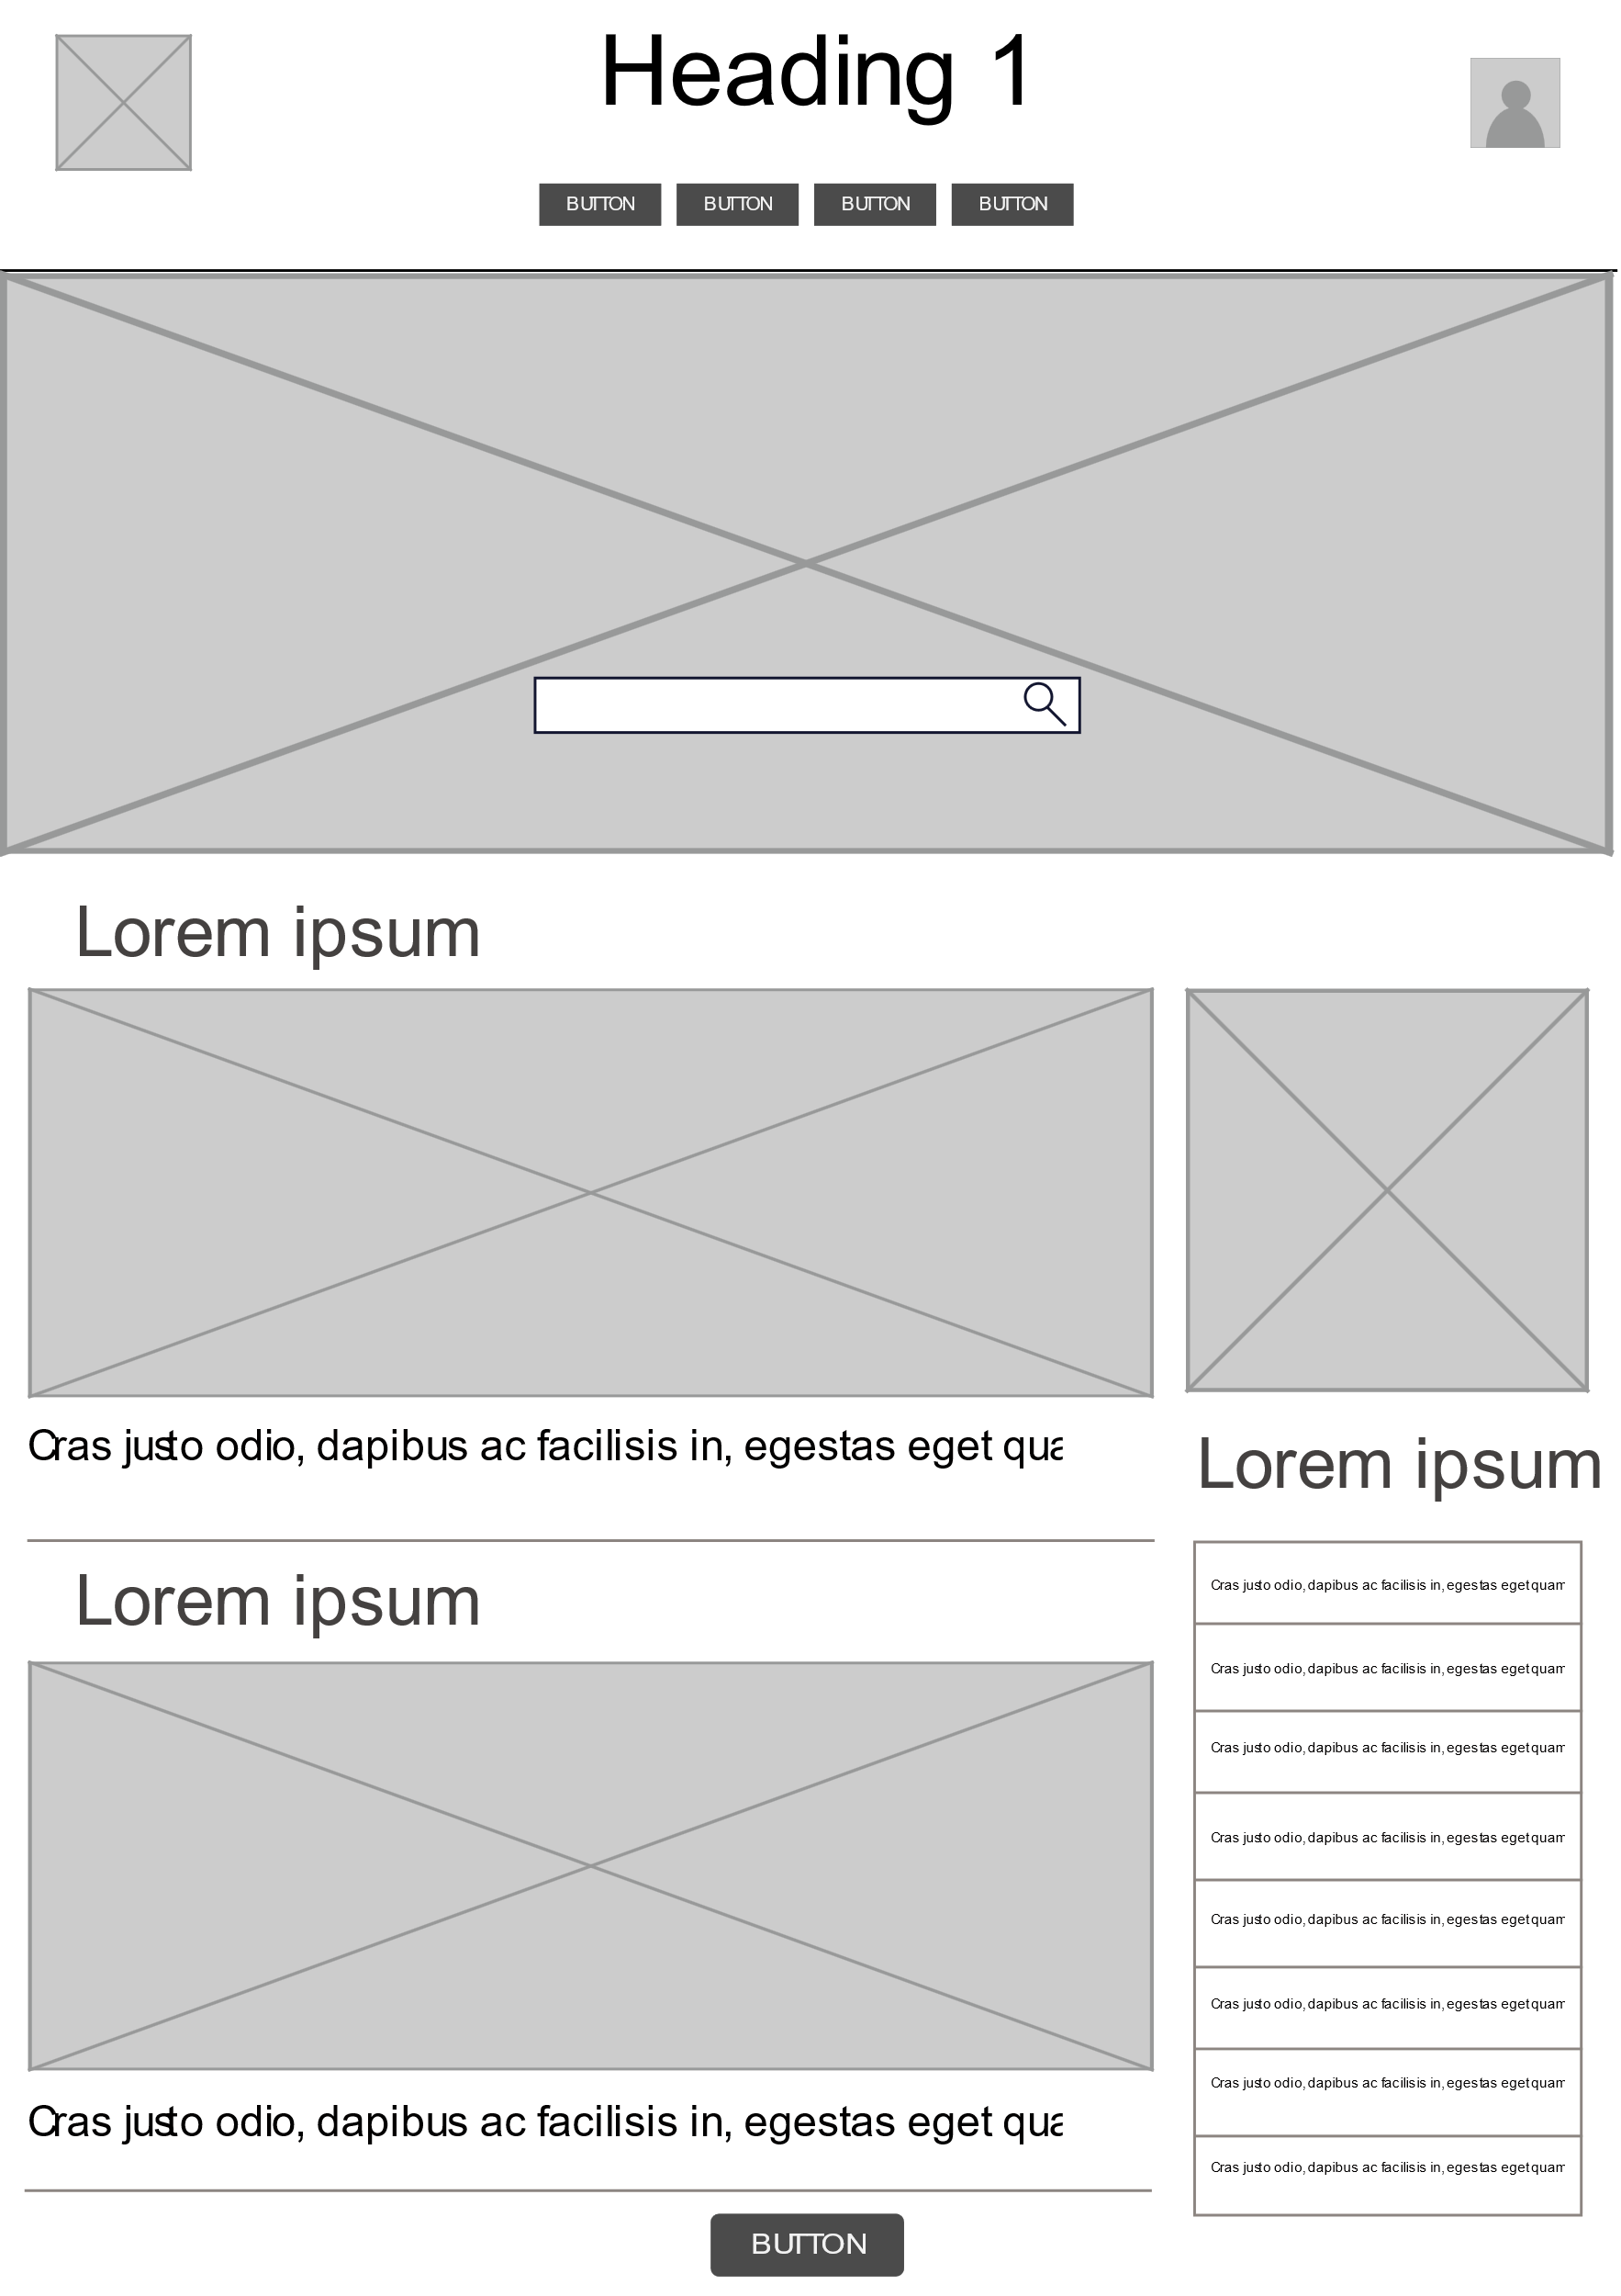

### 

### 

### 

### 3.1.4 Functional Requirements

|  |  |  |
| --- | --- | --- |
| **Spec ID** | **Specification Description** | **Business Rules/ Data Dependency** |
| FR001 | Create a microsite for NASA to raise awareness about space program activity around the world. | *<Any validation rules or business rules>* |
| FR002 | The site must be responsive, and function well on a variety of platforms. |  |
| FR003 | The site should appeal to a specific target audience |  |
| FR004 | Provided links to more information is required |  |
| FR005 | Provided live feeds of launces is required |  |
| FR006 | An HTML5 contact form with Javascript validation is required |  |
| FR007 | The site should be well-designed and easy to use, and conform to WCAG standards. |  |
| FR008 | A Git repository should be set up specifically for this project |  |

*<Note: Section 3.1.4 and section 3.1.5 may be combined if there are a few functionalities on a particular page>*

### 3.1.5 Field level specifications

**Form Elements:**

|  |  |  |  |  |  |  |  |  |  |
| --- | --- | --- | --- | --- | --- | --- | --- | --- | --- |
| **Call-out** | **Field Label** | **UI Control** | **Mand?** | **Editable** | **Data Type** | **Value Set** | **Default Value** | **Data Example** | **Data Source** |
| *<mock-up reference>* | *<Label name>* | *<specify what UI control will be on screen>* | *<specify if field is mandatory>* | *<specify if field is editable>* | *<Specify the data type that will be used for this field>* | *<If value is from the set, specify the entire value set here>* | *<Specify if it should be defaulted to any value>* | *<Provide an example of the data>* | *<Specify the source of the data>* |
| Example:  Call-out 1 | User name | textbox | Yes | Yes | Alpha-numeric | none | NA | John Doe | User entry |
|  | identifier | textbox | Yes | Yes | Alpha-numeric/ Bianary character |  |  | Summer_19 | User entry |
|  | send | button | yes | yes | eventlistener |  |  |  | User entry |
|  | Search | Input text | No | yes | Alpha-numeric |  | NA |  | Any page |
|  | Menu | List (ul) | yes |  | Alpha-numeric |  |  |  | Any page |

**Form Business Rules and Dependencies:**

|  |  |  |  |  |
| --- | --- | --- | --- | --- |
| **Field Label** | **Validation / Business Rules** | **Error Messages** | **Data Dependencies** | **Additional Info/ Notes** |
| First name | First name must meet the required criteria | *“* *Input does not match expected pattern ”* |  |  |
| Last name | Last name must meet the required criteria | *“* *Input does not match expected pattern ”* |  |  |
| Email address | Email address must meet the required criteria | *“* *Input does not match expected pattern ”* |  |  |
| Send | All required input fields must be filled before the user can send any message. | *“All required input fields must be filled”* |  |  |
| Search |  | *“Sorry we couldn’t find any result matching …”* |  |  |
|  |  |  |  |  |
|  |  |  |  |  |

|  |  |  |  |  |  |  |  |
| --- | --- | --- | --- | --- | --- | --- | --- |
| **Button, Link, Icon Label** | **OnClick Event** | **Other Event** | **Visible** | **Enabled Vs Disabled** | **Navigate To** | **Validation** | **Dependencies** |
| *Image* Links | A single mouse click leads | *OnMouseHover*  *Hover effect,*  Cursor pointer | *Yes, always* | *Enabled,* | To another page |  |  |
| Links | A single mouse click leads | *OnMouseHover*  *Hover effect,*  Cursor pointer | *Yes, always* | *Enabled,* | To another page |  |  |
| Logo | A single mouse | *OnMouseHover*  Cursor pointer | *Yes, always* | enable | Home index page |  |  |
| Scroll Back To Top Button | A single mouse click | *OnMouseHover*  *Hover effect,*  Cursor pointer |  |  | Back to top |  |  |
|  |  |  |  |  |  |  |  |

# System Configurations

# Other System Requirements/ Non-Functional Requirements

*<This section is used in contrast with stated functional requirements to highlight the additional details on the quality related aspects as well as other behavioral aspects of a system. This section is used to capture the stakeholders’ implicit expectations about how well the system will work under a given circumstance. Here you can state the specific SLA’s related to system response times (Data search and retrieval), Performance needs and metrics, Latencies in a particular timeframe or during high volume transactions,*

**Buttons, Links and Icons:**

# Reporting Requirements

*<This section is used to capture the reporting needs, including but not limited to the scope and format of the report, data elements and contents required on the report, file types and extraction mechanisms, user base and accessibility levels, frequency of report extractions etc. Also provide the mock up of the report if needed. If necessary, create a separate document for reporting requirements.>*

# Integration Requirements

*<Identify the integration needs and state all required interfaces with anything external to this solution including hardware, software, and users. Include Architectural overview diagrams, high level data flow diagrams, table structures and schema, interface protocols, API’s, Error conditions, Error validations and messaging needs, Auto processing requirements etc. You can optionally state hardware and software dependencies, Upgrade requirements, compatibility issues with existing frameworks and solutions, etc>*

*(Data Flow Diagrams, Interface Diagrams – if necessary)*

## Exception Handling/ Error Reporting

*<This is where you can explain the error conditions/Exceptions that normally happen in Interfaces or cross flow system integrations. Explain the nature of exception, Error Id, Root cause of the error and also the strategy to handle the scenario. You can also indicate if there are any concurrent programs designed to automatically handle the error records or error conditions. State if there are any error reports generated or notifications utilized to alarm the support teams and system Administrators during the interface failures or outages>*

|  |  |  |  |
| --- | --- | --- | --- |
| **Exception/ Error ID** | **Error** | **Cause** | **Solution Strategy** |
|  |  |  |  |

# Data Migration/ Conversion Requirements

*<Explain in brief the data conversion plan. Provide full identifying information for the automated system, application, or situation for which the Data Conversion Plan applies. Describe briefly any assumptions, constraints or risks regarding the data conversion effort. (Provide details in section 1.6)>*

## Data Conversion Strategy

*<Include the overall strategy for the Data Conversion. This includes how and when you will perform the conversion - the approach used to extract, transform and load data during the conversion process, the conversion schedule, and test plan for testing the converted data.>*

## Data Conversion Preparation

*<Provide details on any prerequisites necessary for the conversion. Discuss the backup strategy, restoration process in case the conversion fails.>*

## Data Conversion Specifications

|  |  |  |  |  |  |
| --- | --- | --- | --- | --- | --- |
| **Source** | **Source Data Element** | **Target** | **Target Data Element** | **Conversion Rules** | **Notes** |
| *<Source location>* | *<Source Data Element Identifier >* | *<Target location>* | *<Target Data Element Identifier>* | *<Describe rules for Data conversion>* | *<Additional notes>* |

# References

*<List all references to external material used as background information or knowledge for the FSD. Examples may include a compliancy website, Stanford website, etc>*

# Open Issues

|  |  |  |  |  |  |  |  |
| --- | --- | --- | --- | --- | --- | --- | --- |
| **Issue ID** | **Issue** | **Raised By** | **Raised On** | **Solution/ Decision** | **Resolved By** | **Resolved On** | **Status** |
|  |  |  |  |  |  |  |  |

# Appendix